Name ______________________________________ Date: __________________________________ No: ______
First Name and Last Name Write out the Month Student Number

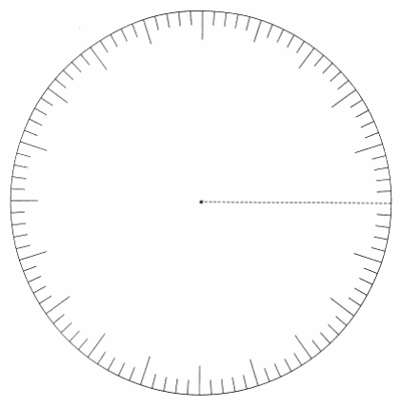
Directions: Be sure to label fraction to decimal, rounding, and decimal to percent. Please find the fraction, decimal, and percent equivalents for the following data. Use ink inside the graph, and colored pencils or highlighters for coloring. Be sure to color a piece of the pie all in one direction, and of course stay within the lines. The Circle Graph is a visual tool with which to examine the data, so neatness counts.

________________________

____________________________________

____________________________________

____________________________________

____________________________________

____________________________________

____________________________________

____________________________________

FRACTION TO DECIMAL

________________
ROUNDING

DECIMAL TO PERCENT

GRAPH

__________________________________________________________ ? ___________________________________
______________  GRAPH  DECIMAL TO PERCENT  ROUNDING  FRACTION TO DECIMAL | _______________  GRAPH  DECIMAL TO PERCENT  ROUNDING  FRACTION TO DECIMAL | ______________  ROUNDING  FRACTION TO DECIMAL  DECIMAL TO PERCENT  GRAPH
_______________  GRAPH  DECIMAL TO PERCENT  ROUNDING  FRACTION TO DECIMAL | ______________  ROUNDING  FRACTION TO DECIMAL  DECIMAL TO PERCENT  GRAPH | _______________  ROUNDING  FRACTION TO DECIMAL  GRAPH  DECIMAL TO PERCENT

